9TH ANNUAL
HOUSTON SHOCK SYMPOSIUM 2027
SCIENTIFIC ADVISORY BOARD

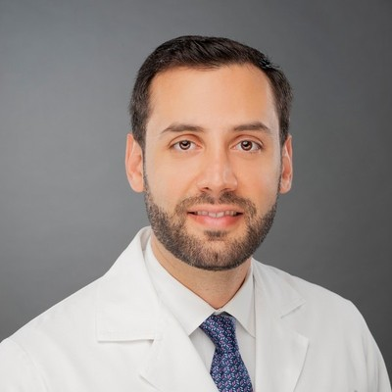 | Marwan Jumean, MD, FACC, FSCAI  President, Houston Shock Symposium  Professor, Department of Cardiology, McGovern Medical School at UTHealth Houston  Program Director, Interventional Heart Failure Training Program, Memorial Hermann–TMC |  | 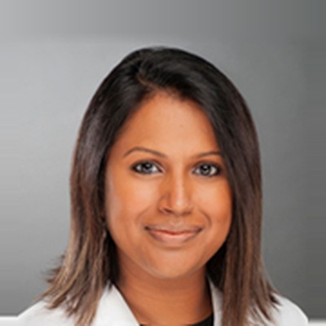 | Bindu Akkanti, MD  Professor of Medicine, Pulmonary, Critical Care and Sleep Medicine, McGovern Medical School at UTHealth Houston  Assistant Dean for Clinical Education, McGovern Medical School  Medical Director, Heart Failure ICU, UTHealth Houston Heart & Vascular Institute
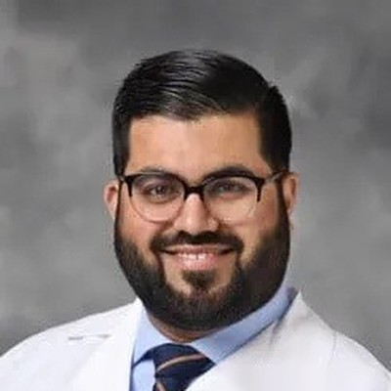 | Mir Babar Basir, DO, FACC, FSCAI  Medical Director, Acute Mechanical Circulatory Support Program  Henry Ford Health, Detroit, MI |  | 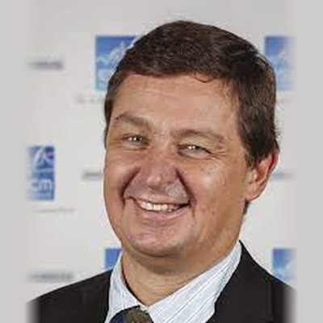 | Daniel De Backer, MD, PhD  Head, Department of Intensive Care, CHIREC Hospitals, Brussels, Belgium  Professor of Intensive Care, Université Libre de Bruxelles  Past President, European Society of Intensive Care Medicine (ESICM)
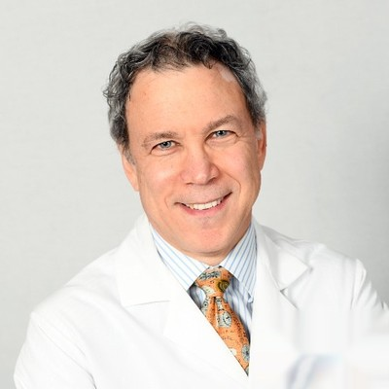 | Steven M. Hollenberg, MD  Cardiology and Critical Care, Massachusetts General Hospital, Boston, MA |  | 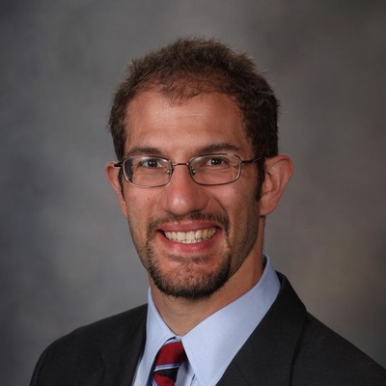 | Jacob C. Jentzer, MD, FACC, FAHA  Associate Professor, Medical College of Wisconsin  Froedtert Hospital, Milwaukee, WI
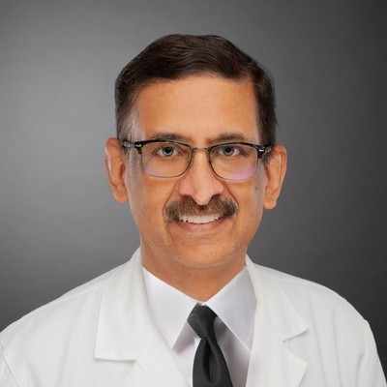 | Biswajit Kar, MD  Professor and Founding Chair, Department of Cardiology, McGovern Medical School at UTHealth Houston  Co-Chair, UTHealth Houston Heart & Vascular; Memorial Hermann Chair |  | 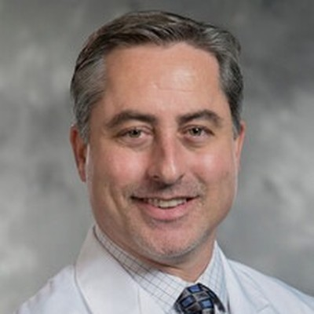 | Jason N. Katz, MD, MHS  Division of Cardiology, Virginia Commonwealth University (VCU Health), Richmond, VA  Inaugural President, Society of Critical Care Cardiology
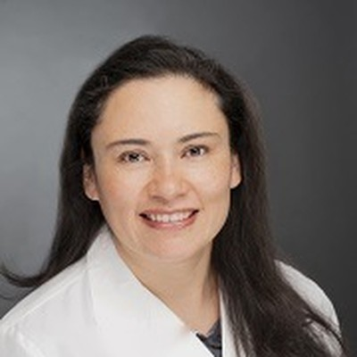 | Maria M. Patarroyo Aponte, MD  Associate Professor, McGovern Medical School at UTHealth Houston  Advanced Heart Failure and Transplant Cardiology, Memorial Hermann–TMC |  | 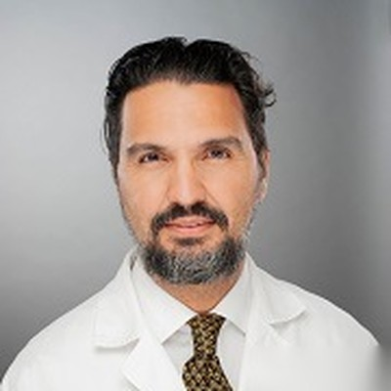 | Ismael A. Salas de Armas, MD  Associate Professor, Cardiothoracic and Vascular Surgery, McGovern Medical School at UTHealth Houston  Center for Advanced Heart Failure, Memorial Hermann–TMC
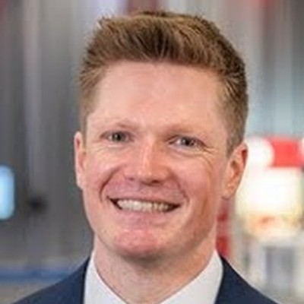 | Benedikt Schrage, MD, PhD, FESC  Department of Cardiology, University Heart & Vascular Center Hamburg  University Medical Center Hamburg-Eppendorf (UKE), Germany |  | 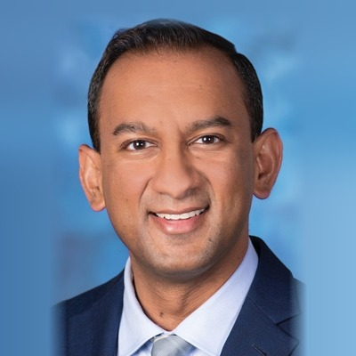 | Shashank S. Sinha, MD, MSc, FACC, FAHA, FHFSA  Medical Director, Cardiac Intensive Care Unit; Director, Cardiovascular Critical Care Research  Inova Schar Heart and Vascular, Inova Fairfax Medical Campus, Falls Church, VA
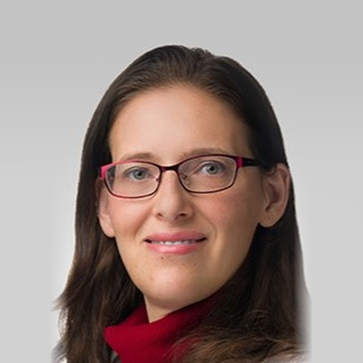 | Esther E. Vorovich, MD, MSCE  Associate Professor of Medicine, Northwestern University Feinberg School of Medicine  Medical Director, Mechanical Circulatory Support Program and Cardiogenic Shock Team, Northwestern Medicine, Chicago, IL

